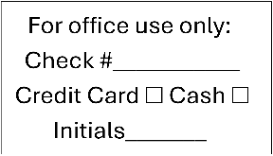
2026 Blue Rapids Community Foundation Match Day Donation Form
DONOR NAME(S)__________________________________________________________
Check here to remain anonymous, no information will be shared with participating funds:
STREET ADDRESS______________________________________ CITY/ST/ZIP_______________________
PHONE______________________________ *EMAIL_____________________________________________
*Indicate email address above to receive an electronic gift acknowledgement for tax purposes. We do not share email addresses.
Write donation amount on the line next to each fund.
For gifts between $25 and $5,000, BRCF will provide a $0.50 match for every $1 donated, up to a maximum match of $2,500 per fund. All eligible gifts will be matched at 50% until the match is depleted.
_____ Alcove Spring _____ Marshall County Fair Association
_____ American Legion Goerge Bedford Post 169 _____ Marshall County Railroad Historical Society
_____ Blue Rapids Chamber of Commerce _____ Mustang Facility Enhancement
_____ Blue Rapids Community Action Team _____ New Hope Evangelical Presbyterian Church
_____ Blue Rapids Community Foundation Building
_____ Blue Rapids Community Watch _____ Pawnee Mental Health Services
_____ Blue Rapids Historical Society & Museum _____ Prospect Hill Cemetery Association
_____ Blue Rapids Methodist Church Foundation _____ RSVP of Northeast Kansas Inc Blue Rapids
_____ Blue Rapids Playground Foundation _____ Schools That Care-Valley Heights USD 498
_____ Blue Rapids Public Library _____ St. Mark’s Episcopal Church Fund
_____ Blue Rapids Rec Board _____ St. Monica-St. Elizabeth Catholic Church
_____ Blue Rapids Swimming Pool _____ Twin Valley-Activity Fund of BR
_____ Blue Rapids Tree Board _____ United Presbyterian Church USA of BR
_____ Fairmount Cemetery _____ USD 498 Foundation
_____ Greenwood Cemetery _____ Valley Heights Booster Club
If paying by check, please write ONE CHECK made out to Blue Rapids Community Foundation (BRCF) for the TOTAL amount of your donation.
TOTAL DONATION: $_________________________________

- If paying online visit BlueRapidsMatchDay.com to complete your transaction.
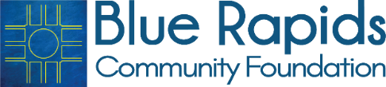
- If paying by check, please include a completed donation form with your check when you mail to the BRCF at PO Box 63, Blue Rapids, KS 66441. Checks must be received by Sept. 14, 2026.

The Blue Rapids Community Foundation is an affiliate of the Greater Manhattan Community Foundation. The Greater Manhattan Community Foundation is a non-profit 501(c) (3) organization — EIN #48-1215574, incorporated in the State of Kansas.

